ICM – Computer Science Major

M1 Cyber Physical and Social Systems

Course unit on Data Interoperability and Semantics

Tutorial 1

1) Bluetooth Mesh Model
The definitions below are extracts of a Bluetooth standard. Complete the tables.

Bluetooth Mesh Model specification v1.0.1 Section 3.1.6.1 Generic Battery Level (modified)
The Generic Battery Level state is a value ranging from 0 percent through 100 percent. The values must be divided by two (ex., 0x03 stands for 1.5 %). Values above 0xC8 (100 %) are forbidden.

 | encoded | decoded
8-bit unsigned integer  (UINT8) | 0xA7 (hexa)  0b 1010 0111 = 167 | 83.5 %
UINT8 | 0b01010110 (binary)  64+16+4+2 = 86 | 43 %

Bluetooth Mesh Model specification v1.0.1 Section 3.1.7.6 Local Altitude
The Local Altitude field determines the altitude of the device relative to the Generic Location Global Altitude. This is a 16-bit signed integer in decimeters. The valid range is from -32768 decimeters (0x8000) through 0 decimeters (0x0000) up to 32765 decimeters (0x7FFD).
The following formula can be used to decode data: $B2T\left(X\right)=-x_{w-1}∙2^{w-1}+\sum_{i=0}^{w-2}{x_{i}∙2^{i}}$

 | encoded | decoded
INT16 - Big Endian (AB) | 0x8001 | We know 0x8000 = -32768 dm  +1 -32767 dm
INT16 - Little Endian (BA) | 0x8001 0x0180  0b 0000 0001 1000 0000 | 256 + 128 = 384 dm

2) IEEE 754
Decode the following hexadecimal strings using the Single precision IEEE 754 floating-point standard:
you can try with https://www.h-schmidt.net/FloatConverter/IEEE754.html

- 0x3F000000
3F 00 00 00 ₁₆ = 0011 1111 00…₂ // first convert to binary
= 0 0111 1110 0…₂ // group bits differently
S = 0 E = 1000 0000₂ - 2₁₀ = 128 – 2 = 126₁₀ M = 0 // extract sign, exponent, mantissa
apply formula: -1⁰ x 2⁽¹²⁶⁻¹²⁷⁾ x 1.0 = 0.5 ₁₀

b) 0x44800000
44 80 00 00 ₁₆ = 0100 0100 1000 00.. ₂ // first convert to binary
= 0 1000 1001 0.. ₂ // group bits differently
S = 0 E = 1000 1001 ₂ = 128 + 8 + 1 = 137₁₀ M = 0 // extract sign, exponent, mantissa
apply formula: -1⁰ x 2⁽¹³⁷⁻¹²⁷⁾ x 1.0 = 2¹⁰ = 1024 ₁₀

Encode the following numbers using the Single precision IEEE 754 floating-point standard:
c) -3.0
-3.0 = -1 x 2 x 1.5 // in the form of "sign" x "power of two" x "number between 1 and 2"
= (-1)¹ x 2^{(128 – 127)} x (1 + 2⁻¹) = (-1)¹ x 2^{(128 – 127)} x 1.1₂ // IEEE 574 floating point formula
S = 1 E = 128₁₀ = 1000 0000 ₂ M = 1000…₂ // explicit components
0 1000 0000 100…₂ = 0100 0000 0100 00…₂ = 40 40 00 00 ₁₆

d) 24.0
24.0 = 1 x 16 x 1.5 // in the form of "sign" x "power of two" x "number between 1 and 2"
= (-1)⁰ x 2⁽¹³¹ ⁻ ¹²⁷⁾ x 1.1₂ // IEEE 574 floating point formula
S = 0 E = 131₁₀ = 128 + 2 + 1 = 1000 0011₂ M = 1000..₂ // explicit components
0 1000 0011 1000..₂ = 0100 0001 1100 0…₂ = 41 C0 00 00 ₁₆

3) UTF-8
Convert the following strings to UTF-8:
- cs
This is two characters ! Not a strange, unique character
Code point for 'c' is U+0063, code point for 's' is U+0073.
Both are encoded on one byte only.
So the encoding of "cs" is 63 73₁₆
check with command echo -n cs | od -t x1
- ¥
Code point is U+00A5 (1010 0101₂)
Encoded on two bytes, with mask 110xxxxx 10xxxxxx
So the encoding is 11000010 10100101₂ = C2 A5 ₁₆
check with command echo -n ¥ | od -t x1
- €
Code point is U+20AC (0010 0000 1010 1100₂)
Encoded on three bytes as per the UTF-8 spec, with mask 1110xxxx 10xxxxxx 10xxxxxx
so the encoding is 11100010 10000010 10101100₂ = E2 82 AC ₁₆
check with command echo -n € | od -t x1
- 😃
Code point is U+1F603 (0001 1111 0110 0000 0011₂)
Encoded on four bytes as per the UTF-8 spec, with mask 11110xxx 10xxxxxx 10xxxxxx 10xxxxxx
so the encoding is 11110000 10011111 10011000 10000011₂ = F0 9F 98 83 ₁₆
check with command echo -n 😃 | od -t x1

4) CBOR
Below is a document encoded using the Concise Binary Object Representation.
Write a JSON equivalent of this document.
Spaces and new lines in the representation are just there to help you.

82 A3 61 76 FA 3F800000 62 6363 63 455552 62 6373 63 E282AC
A3 61 76 FA 40F80000 62 6363 63 434E59 62 6373 62 C2A5

I will use notation x_y with x the major CBOR type encoded on 3 bits, and y the reminder on 5 bits.

let's decode byte by byte:
82₁₆ = 4_2 , announces an array of two items.
A3₁₆ = 5_3 , announces an object of three key-value pairs
61₁₆ = 3_1 , announces an UTF-8 text string encoded on 1 byte
76₁₆ is the UTF-8 text string. A quick look up to table 1 gives character "v" – this is the first key
FA₁₆ = 111_11010 = 7_26, announces a IEEE 754 Single-Precision Float (next 32 bits = 4 bytes)
3F800000₁₆ is an IEEE 754 Single-Precision Float
= 0011 1111 10…₂ // first convert to binary
= 0 0111 1111 0…₂ // group bits differently
S = 0 E = 127₁₀ M = 0 // extract sign, exponent, mantissa
apply formula: -1⁰ x 2⁽¹²⁷⁻¹²⁷⁾ x 1.0₂ = 1.0 ₁₀ – this is the first value
62₁₆ = 3_2, announces an UTF-8 text string encoded on 2 bytes
6363₁₆ is the UTF-8 text string. A quick look up to table 1 gives characters "cc"– this is the second key
63₁₆ = 3_3, announces an UTF-8 text string encoded on 3 bytes
455552₁₆ is the string: "EUR" – this is the second value
62₁₆ = 3_2, announces an UTF-8 text string encoded on 2 bytes
6373₁₆ is the string: "cs" – this is the third key
63₁₆ = 3_3, announces an UTF-8 text string encoded on 3 bytes
E282AC₁₆ is the string "€" (see exercise 3c above) – this is the third value
so first object in JSON is {"v": 1.0, "cc": "EUR", "cs": "€"}

let's do the same for the second object:
first key is "v"
first value is IEEE 754 Single-Precision Float 40F80000₁₆
= 0100 0000 1111 1000 00…₂ // first convert to binary
= 0 1000 0001 1111 0…₂ // then group bits differently
S = 0 E = 128 + 1₁₀ = 129 M = 1111 0…₂ // extract sign, exponent, mantissa
apply formula: -1⁰ x 2⁽¹²⁹⁻¹²⁷⁾ x 1.1111₂
= 4₁₀ x 1.1111₂ ("4 times 1 dot something)
// looks lengthy to compute 1 + 0.5 + 0.25 + 0.125 + 0.0625. let's transform that a bit
= 2 x 11.111₂ ("2 times 3 dot something)
= 111.11₂ // the entire part is 111₂ = 7 , the fraction part is 0.5 + 0.25
= 7.75₁₀
second key is "cc"
second value is "CNY"
third key is "cs"
third value is "¥"

In the end, we get JSON document
[{"v": 1.0, "cc": "EUR", "cs": "€"}, {"v": 7.75, "cc": "CNY", "cs": "¥"}]

check on cbor.me:
82 # array(2)
A3 # map(3)
61 # text(1)
76 # "v"
FA 3F800000 # float
62 # text(2)
6363 # "cc"
63 # text(3)
455552 # "EUR"
62 # text(2)
6373 # "cs"
63 # text(3)
E282AC # "€"
A3 # map(3)
61 # text(1)
76 # "v"
FA 40F80000 # float
62 # text(2)
6363 # "cc"
63 # text(3)
434E59 # "CNY"
62 # text(2)
6373 # "cs"
62 # text(2)
C2A5 # "¥"

5) Base32 decoding

Below is the RFC 4648 Base32 Alphabet
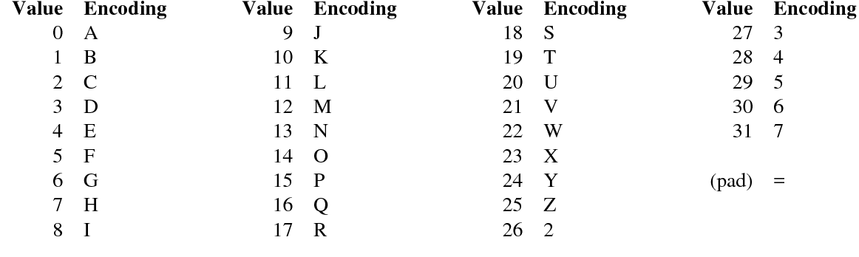

Decode the following string: JVSWK5BAJJXWKICAGRYG2II=

you can test with echo JVSWK5BAJJXWKICAGRYG2II= | base32 -d

simple look up in the alphabet
9, 21, 18, 22, 10, 29, 1, 0, 9, 9, 23, 22, 10,
01001 10101 10010 10110 01010 11101 00001 00000 01001 01001 10111 10110 01010

8, 2, 0, 6, 17, 24, 6, 26, 8, 8
01000 00010 00000 00110 10001 11000 00110 11010 01000 01000

Groups of 8 bits:
01001101 01100101 01100101 01110100 00100000 01001010 01101111 01100101
4 D 6 5 6 5 7 4 2 0 4 6 6 7 6 5
0x4D=M 0x65=e 0x65=e 0x74=t 0x20=spce0x46=J 0x67=o 0x65=e

00100000 01000000 00110100 01110000 01101101 00100001 000 (pad = : we forget about the three last zeros)
2 0 4 0 3 4 7 0 6 D 2 1
0x20=spce0x40=@ 0x34=4 0x70=p 0x6D=m 0x21=!

The answer is:
Meet Joe @4pm!

6) CRLF
Different OSs represent ends of line differently.
Microsoft Windows uses CRLF, Unix uses only LF, Classic MacOS used CR, then LF since Mac OS X.

a) What is the full name of CR and LF? Carriage Return and Line Feed
b) What are their ASCII codes? simple lookup in Annex 3: CR: 0D₁₆ LF: 0A₁₆
c) With what escape characters can these characters be included in a JSON string? \r and \n
d) Why is it problematic that different OSs use different end-of-line characters?
It causes inconsistencies when sharing or processing text files across systems. For example, files may appear as a single long line or have extra blank lines if applications do not correctly handle the end-of-line convention. This is an interoperability problem! (in the title of the course )

Appendix A: Single precision IEEE 754 floating-point standard
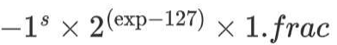
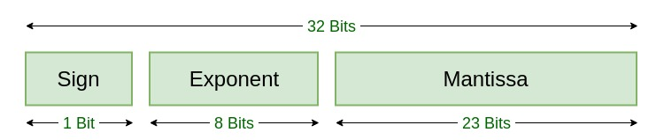

As an example, the value for number 0xbfc00000 is -1.5

Appendix B: UTF-8 Encoding
UTF-8 encodes code points in one to four bytes, depending on the value of the code point. In the following table, the x characters are replaced by the bits of the code point:
Code point ↔ UTF-8 conversion
First code point | Last code point | Byte 1 | Byte 2 | Byte 3 | Byte 4
U+0000 | U+007F | 0xxxxxxx
U+0080 | U+07FF | 110xxxxx | 10xxxxxx
U+0800 | U+FFFF | 1110xxxx | 10xxxxxx | 10xxxxxx
U+10000 | U+10FFFF | 11110xxx | 10xxxxxx | 10xxxxxx | 10xxxxxx
The first 128 code points (ASCII) need one byte. The next 1,920 code points need two bytes to encode, which covers the remainder of almost all Latin-script alphabets, and also IPA extensions, Greek, Cyrillic, Coptic, Armenian, Hebrew, Arabic, Syriac, Thaana and N'Ko alphabets, as well as Combining Diacritical Marks. Three bytes are needed for the remaining 61,440 code points of the Basic Multilingual Plane (BMP), including most Chinese, Japanese and Korean characters. Four bytes are needed for the 1,048,576 code points in the other planes of Unicode, which include emoji (pictographic symbols), less common CJK characters, various historic scripts, and mathematical symbols.
A "character" can take more than 4 bytes because it is made of more than one code point. For instance a national flag character takes 8 bytes since it is "constructed from a pair of Unicode scalar values" both from outside the BMP.
Encoding process
In these examples, character ‘|’ indicate how bits from the code point are separated and distributed among the UTF-8 bytes. Additional bits added by the UTF-8 encoding process are underlined.
- The Unicode code point for the euro sign € is U+20AC.
- As this code point lies between U+0800 and U+FFFF, this will take three bytes to encode.
- Hexadecimal 20AC is binary 0010 | 0000 10|10 1100. The two leading zeros are added because a three-byte encoding needs exactly sixteen bits from the code point.
- Because the encoding will be three bytes long, its leading byte starts with three 1s, then a 0 (1110...)
- The four most significant bits of the code point are stored in the remaining low order four bits of this byte (11100010), leaving 12 bits of the code point yet to be encoded (...0000 10|10 1100).
- All continuation bytes contain exactly six bits from the code point. So the next six bits of the code point are stored in the low order six bits of the next byte, and 10 is stored in the high order two bits to mark it as a continuation byte (so 10000010).
- Finally the last six bits of the code point are stored in the low order six bits of the final byte, and again 10 is stored in the high order two bits (10101100).
The three bytes 11100010 10000010 10101100 can be more concisely written in hexadecimal, as E2 82 AC.

Appendix C: Some Unicode code points

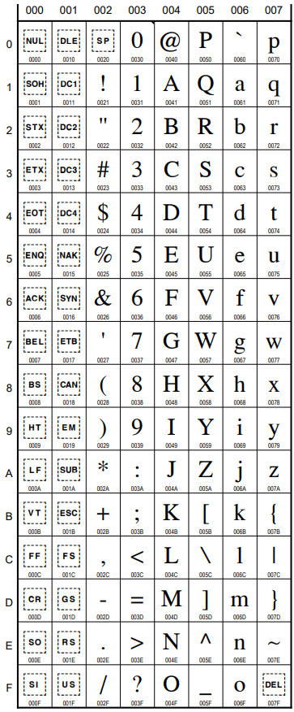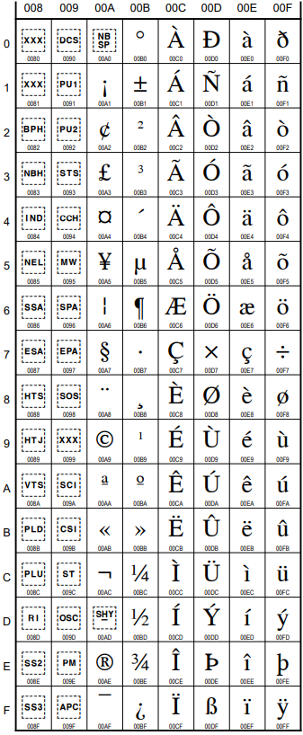
Basic Latin Range: U+0000 – U+007F Latin-1 Supplement: U+0080 – U+00FF

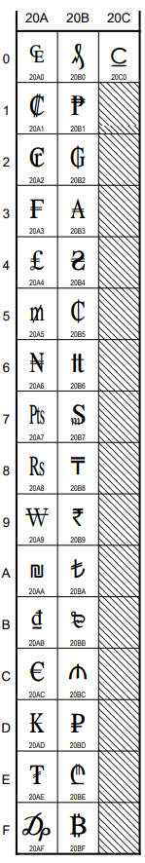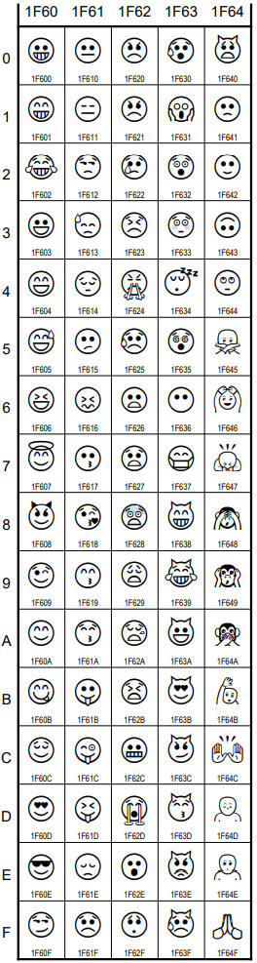
Currency Symbols U+20A0 – U+20C0 Emoji symbols U+1F600 – U+1F64F

Appendix D: RFC 8949 - Concise Binary Object Representation (CBOR)

Concise Binary Object Representation (CBOR) is a binary data serialization format loosely based on JSON authored by C. Bormann. Like JSON it allows the transmission of data objects that contain name–value pairs, but in a more concise manner. This increases processing and transfer speeds at the cost of human readability. It is defined in IETF RFC 8949

Specification of the CBOR encoding
CBOR encoded data is seen as a stream of data items. Each data item consists of a header byte containing a 3-bit type and 5-bit short count. This is followed by an optional extended count (if the short count is in the range 24–27), and an optional payload.

For types 0, 1, and 7, there is no payload; the count is the value. For types 2 (byte string) and 3 (text string), the count is the length of the payload. For types 4 (array) and 5 (map), the count is the number of items (pairs) in the payload.

CBOR cheatsheet
Major type Description Binary Shorthand
0 an unsigned integer 000_xxxxx unsigned(#)
1 a negative integer 001_xxxxx negative(#-1)
2 a byte string 010_xxxxx bytes(n)
3 a text string (UTF-8) 011_xxxxx text(n)
4 an array of data items 100_xxxxx array(n)
5 a map of pairs of data items 101_xxxxx map(n)
7 Floating-point numbers and values with no content 111_xxxxx simple(v)

¹ For negative(#-1), # represents the negative value minus 1. For example, negative(4) represents a value of -5.
⁵ For map(n), n represents number of key/value pairs.

Unsigned integer
Number Hex
0 .. 15 00 .. 0F
16 .. 23 10 .. 17
24 .. 255 18 18 .. 18 FF
256 .. 65535 19 0100 .. 19 FFFF

Negative integer
Number Hex
-1 .. -16 20 .. 2F
-17 .. -24 30 .. 37
-25 .. -256 38 18 .. 38 FF
-257 .. -65536 39 0100 .. 39 FFFF

Array
Length Hex
0 .. 15 80 .. 8F
16 .. 23 90 .. 97
24 .. 255 98 18 .. 98 FF
256 .. 65535 99 0100 .. 99 FFFF
Indefinite 9F
Length represents number of key/value pairs.

Map
Length Hex
0 .. 15 A0 .. AF
16 .. 23 B0 .. B7
24 .. 255 B8 18 .. B8 FF
256 .. 65535 B9 0100 .. B9 FFFF
Indefinite BF
Length represents number of key/value pairs.

Floating point numbers and values with no content
5-Bit Value Semantics
20 false
21 true
22 null
23 undefined
25 IEEE 754 Half-Precision Float (16 bits follow)
26 IEEE 754 Single-Precision Float (32 bits follow)
27 IEEE 754 Double-Precision Float (64 bits follow)
31 "break" stop code for indefinite-length items

Examples:

As JSON:  {  "t":2,  "h":null  } | As CBOR:  A2 # map(2)  61 # text(1)  74 # "t"  02 # unsigned(2)  61 # text(1)  68 # "h"  F6 # primitive(22)

